AN AUTONOMOUS CEILING CLEANING ROBOT
This invention provides a robotic device (20), known as an autonomous ceiling cleaning robot, which is designed for cleaning the ceiling surface, monitoring the cleaning area in real time, detecting obstacles on its way and safe movement over the ceiling surface. The autonomous ceiling cleaning robot includes robot base frame (11) and tires (8) used to move the robot over the ceiling surface. The ultrasonic sensor (1) is designed to detect obstacles in front of the robot, while the camera module (2) is intended for taking photos and videos of the ceiling surface for further monitoring of the cleaning area. The IR sensor (7) is used to detect the ceiling surface and help identify the boundaries of the cleaning area. The STM32 controller (5) is intended to analyze the information received by sensors and control the robot's work on the basis of predetermined instructions. The ESP8266 Wi-Fi module (6) provides wireless communication and allows the user to send movement commands to the robot. The motor driver (15) is used to control the DC motor (4).The telescopic arm assembly consists of telescopic arm base (10), telescopic arm shoulder (12), telescopic arm elbow (13), and telescopic arm head (14) for placing the cleaning system at various places and angles. A servo motor (16) has been provided in order to provide a control for the motion of the telescopic arm assembly. A cleaning brush (3) mounted on the telescopic arm head (14) is designed for removing dust, dirt, and cobwebs from the ceiling surface. A power source (9) and battery (17) have been provided for supplying electrical power to the robot.

3D DIAGRAM
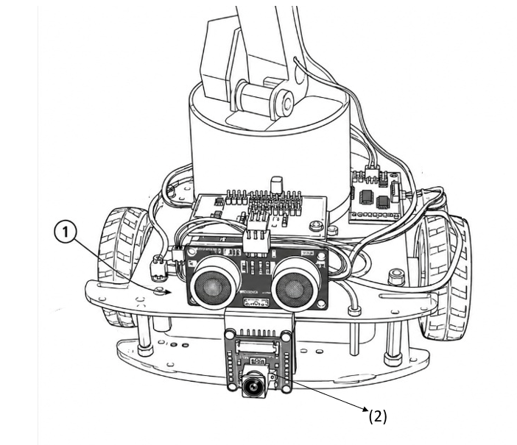
Fig 1 : The Front view of the ceiling cleaning robot, according to the present invention.
The layout of sensors and cameras on the ceiling cleaning robot which we have designed is illustrated in Fig. 1 below. The sensors and monitors are integrated with the electronic control systems inside the robot structure. The robot is able to detect obstacles as well as monitor its surroundings while in motion during the cleaning process. The ultrasonic sensor and the camera module are fixed at the front of the robot, while the control unit and battery power source components are placed in the robot body to ensure proper operation and safety of the cleaning process.
The ultrasonic sensor (1), fixed at the front of the robot, is the sensing component used to sense the distance from the robot to the surrounding obstacles. The sensor will give the information on distance to the control system to enable the safe navigation of the robot. The camera module (2) is fixed at the front side of the robot, and it captures the visual information of the surrounding environment for monitoring purposes. Ultrasonic sensor (1) and Camera Module (2) have been mounted on the front portion of the robot for aiding obstacle detection and environment monitoring for autonomous cleaning of the ceiling robot, as shown in Fig. 1.

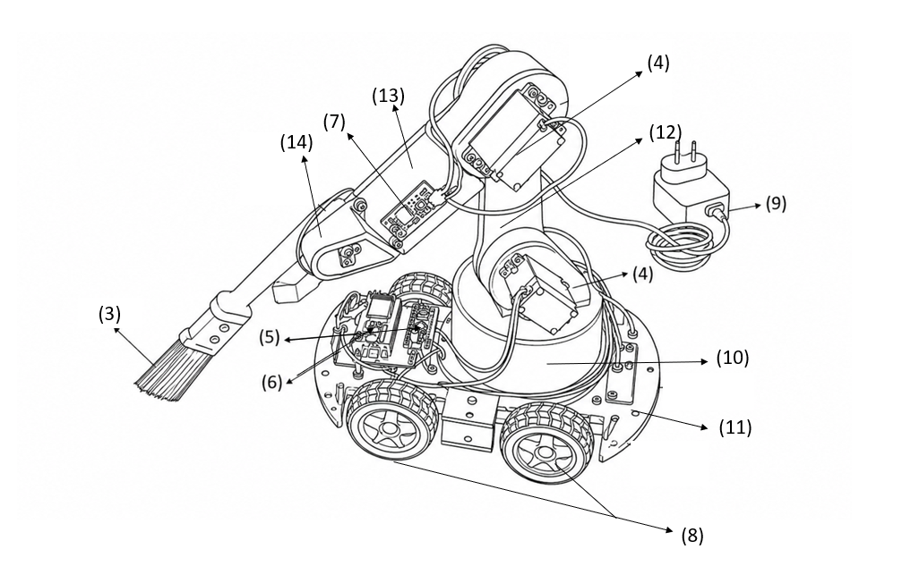
Fig.2a: The isometric view of the ceiling cleaning robot, according to the present invention.
The isometric view of the ceiling cleaning robot in accordance with the invention is depicted in Fig 2a. The ceiling cleaning robot consists of a robot base frame (11), a number of tires (8), DC motors (4), power source (9), a battery (17), motor driver (15), STM32 controller (5), ESP8266 Wi-Fi Module (6), IR sensor (7), and a telescopic cleaning arm. The telescopic cleaning arm consists of a telescopic arm base (10), telescopic arm shoulder (12), telescopic arm elbow (13), telescopic arm head (14), and a servo motor (16). Robot base frame (11) comprises the primary structural support of the robot and houses the control, power, and mechanical subsystems. Tyres (8) are provided in the lower portion of the robot and are powered by the DC motors (4) in order to drive the robot in the desired direction. Motor driver (15) is electrically connected with the STM32 controller (5) and the DC motors (4) to control the motion of the robot. The battery (17) and power supply (9) supply the requisite electrical power to the controller, sensors, motors, and other systems of the robot.
STM32 controller (5) works as the primary controller of the robot and is programmed to process the inputs generated from the sensors and generates control signals for operating the motors and the cleaning mechanism of the robot. The ESP8266 Wi-Fi module (6) enables wireless communication between the robot and the user interface. The IR sensor (7) is provided on the robot structure for sensing the obstacles and ensuring safe motion of the robot. The telescopic arm base (10) is mounted onto the robot base frame (11) and acts as the support for the telescopic cleaning arm. The telescopic arm shoulder (12) and telescopic arm elbow (13) offer the necessary motion and positioning of the arm. The telescopic arm head (14) is installed at the end portion of the arm and is responsible for carrying the cleaning mechanism. The servo motor (16) is designed to actuate the motion and positioning of the telescopic arm so that it reaches the necessary ceiling areas for cleaning purposes.
The combination of the DC motors (4), STM32 controller (5), ESP8266 Wi-Fi module (6), IR sensor (7), tyres (8), power supply (9), telescopic arm base (10), robot base frame (11), telescopic arm shoulder (12), telescopic arm elbow (13), telescopic arm head (14), motor driver (15), servo motor (16), and battery (17) forms an integrated structure that allows for performing the ceiling cleaning operation, as shown in Fig. 2a.
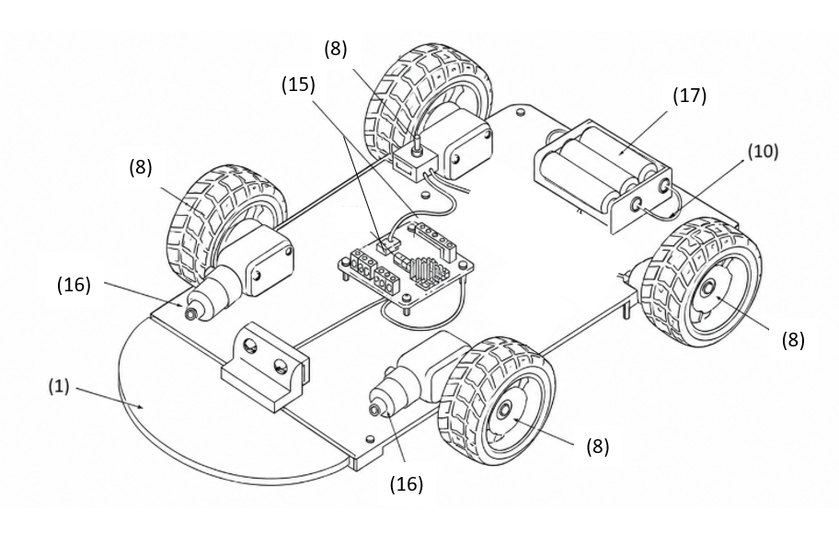
Fig.2b., The bottom isometric view of the ceiling cleaning robot showing the drive and power system, according to the present invention.
Isometric view of the bottom of the ceiling cleaning robot in accordance with the present invention is illustrated in Fig. 2b. The ceiling cleaning robot includes a robot base frame, multiple tyres, DC motors, motor driver, and battery arranged in the lower part of the robot. The above-listed components facilitate the stable movement and provide the needed power for the robot during the ceiling cleaning operation.
The tyres (8) are positioned on the sides of the robot base and are adapted for moving the robot. The DC motors (16) are attached to the tyres (8) and are adapted for providing the drive of the robot. The motor driver (15) is arranged in the robot base and is adapted for controlling the DC motors (16) with the help of the signals received by the STM32 controller. Battery (17) is fixed to the robot base and is designed to provide electrical energy to the controller, motor driver, sensors, and other electrical elements of the robot. Robot base frame gives mechanical support to drive and power elements and holds the elements in their place during the process of operation. The tyre assembly (8), motor driver (15), DC motors (16), battery (17), and robot base construction ensure the stable movement and proper power distribution of the autonomous ceiling cleaning robot, as shown in Fig. 2b.,

